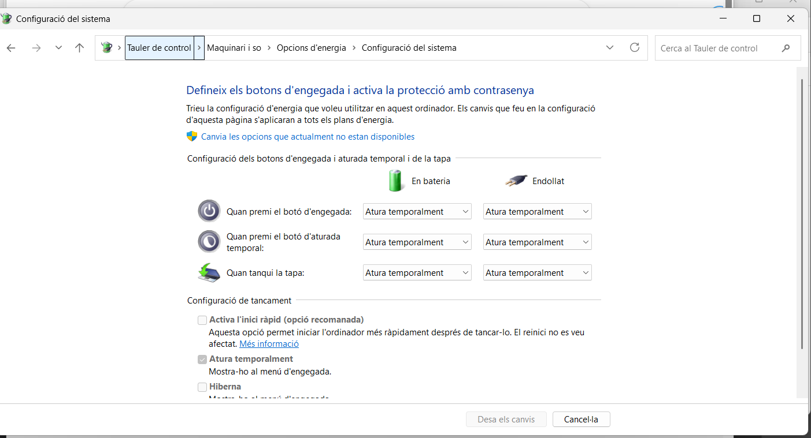

Bios - we are talking about the bios and how to start the system
Capture for every step , now we are - f1 to access to bio
Think pad bios minimal conf - with the hardware - we need to use this to conf

So we can use the bios to conf the machine -
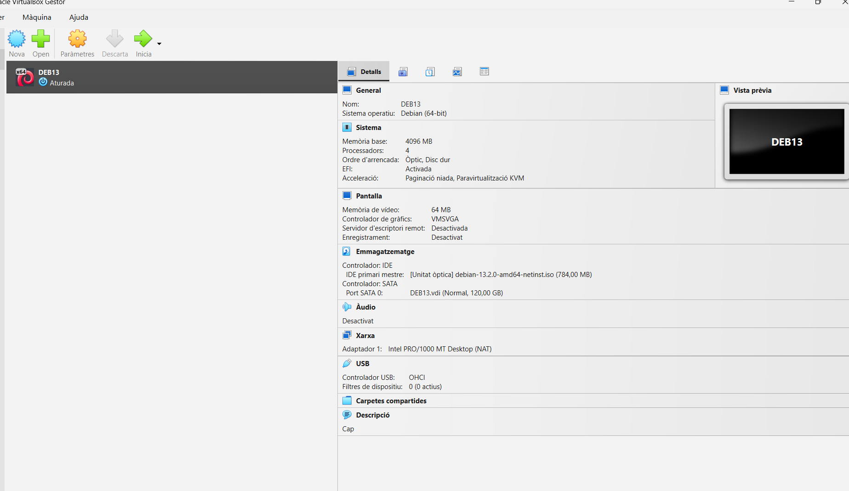

We are virtual needs type be assessed

We need to install apache to the virtual machine . This is very urgent. We need to justify the install through the screen captures … the teacher says we need to identify the problems.

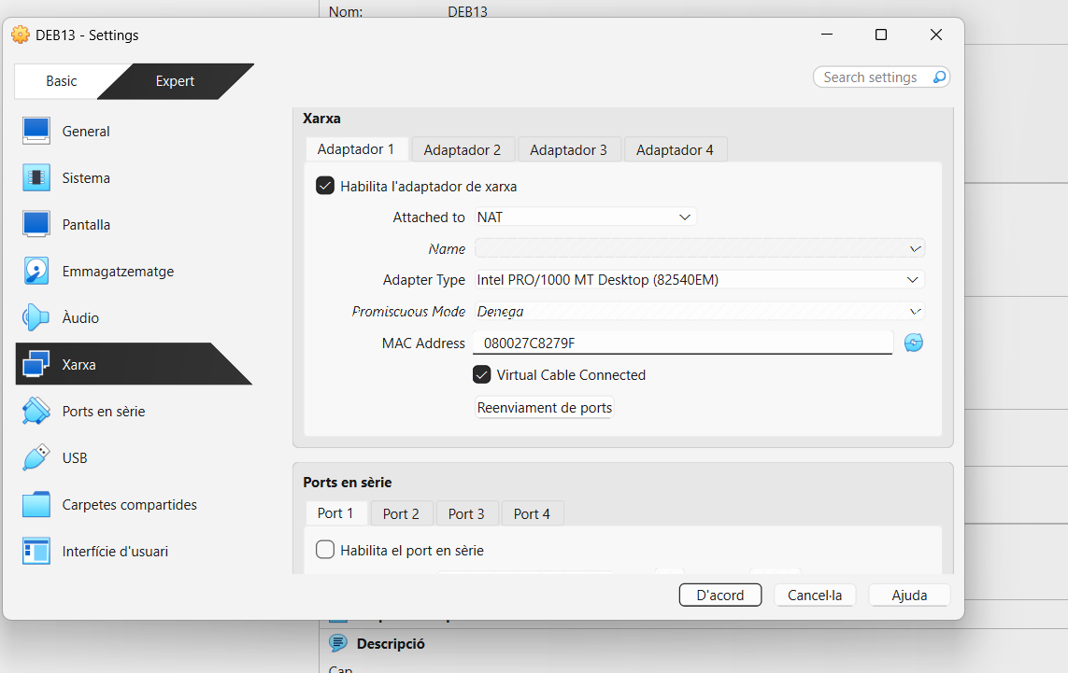

MAC address change of names - it comes with xarxa
Via commands you can conf up to 8 cards
Adaptador puente

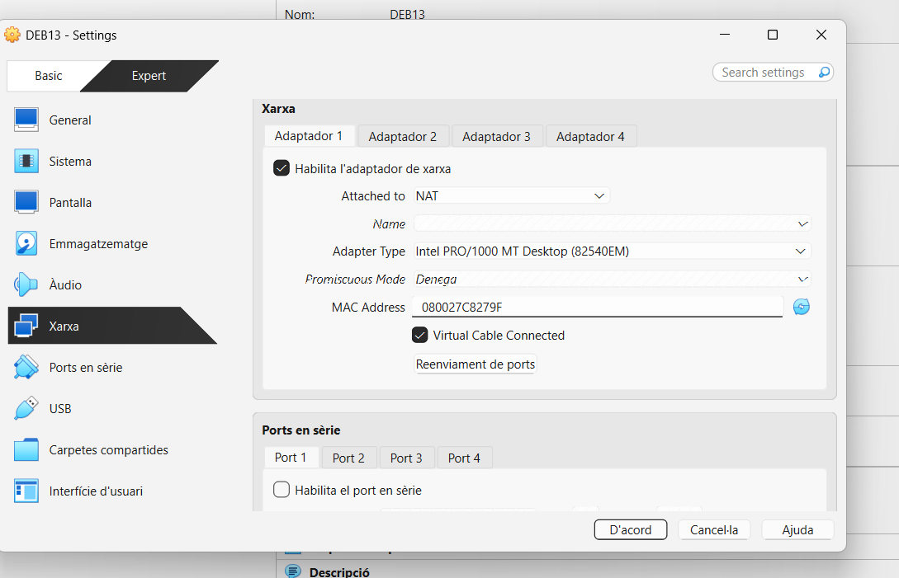
We are going to use a bridged connection

Exercise
Respostes en blau - dod

aalacala2@inspalamos.cat

Share - links for editor - share folder
Ortografia - castellano - texto azul

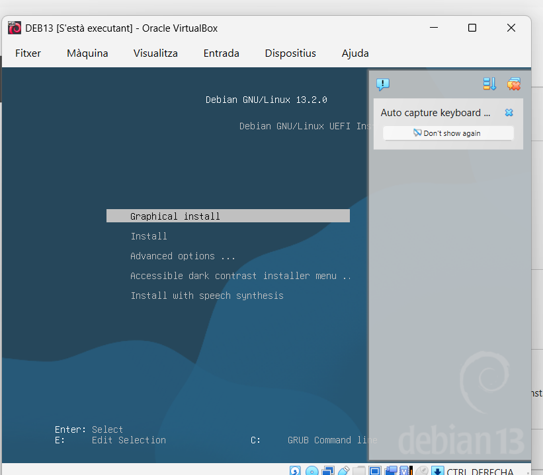

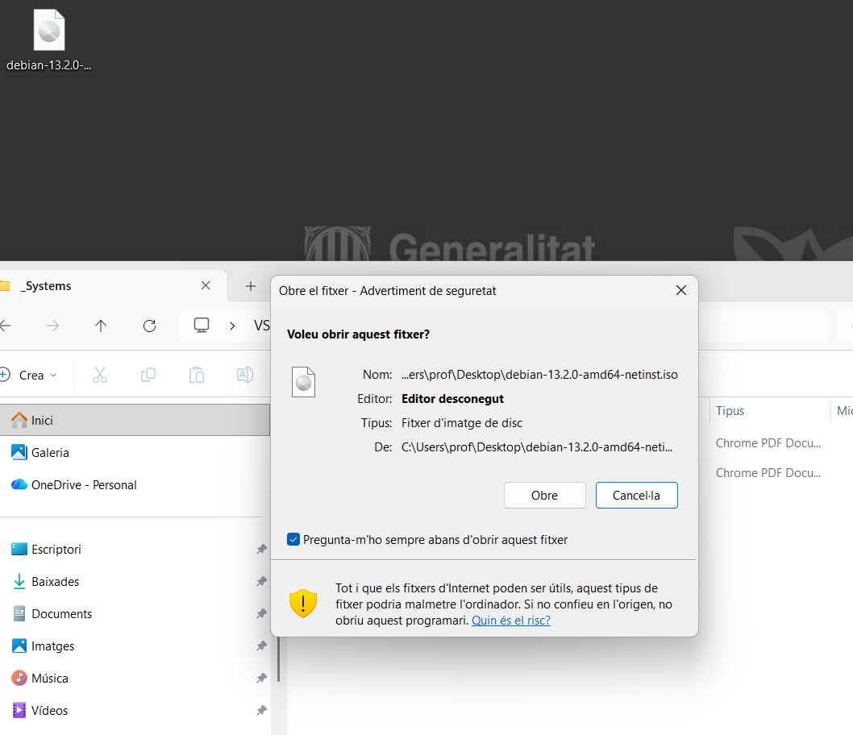
Versiones sobre small version - full version - complete
750 mb that s the versions - compressed - dimamica - interactive - esta in internet - i la gran instalacion esta en internet

Instalacion - el modulo es externo en un s servidor externo - ask for the technique plexin muxin

Cuando se instala el sistema operativo - arranque externo - des de medio no volatil a la ram y de la ran a la cpu … el software se ejecuta des la ram
En un life el disco duro esta en un periferico - y els disco - esta libre - tenemos que se deshabilitar en windows para que nos deje acceder al disco como memoria.
Particiones - trabajamos de una particion
Particiones de la memoria: explicación de como se corpamentan el disco general…. Sistemas de ficheros -
NTFS - EXT4 - - HFS
XFS usuario control acceso
FAT - 4 gb

Live from the usb - to repair because we get access to the disk as storge.
Cloud

Magnetico - rotacion
Uefi - particiones del disco
Crear tabla de particiones … 128 max
Lvm logical volume manage - stack - physical memory can be joined
/boot/uefi - FAT
Windows manager windows manager loader - space 1gb inside the windows machine

Mbr master boot record

M2 , ssd electronic matrix
/ root
/ swap - area de intercambio - servidor web -
/var/ logs - entries - we need to separate the the distribution …
User partition for user
/home/users
Flooding - spam
System and logs need to differentiated
Ddos - denegación de servicio

Exchange of hd and ram - swapping -

